PROJECT | VIVADIM3
VIVALIA – DIM3 : | USE AND ECONOMICAL IMPACT OF DIM3 CLINICAL NUTRITION SYSTEM
PROTOCOL VERSION : | DRAFT 0.1
DATE | 21/5/23

Note : this is draft version to be used as a convergence tool between Vivalia entities and Dim3.
Once consensus on basic steps will be achieved the protocol sensu stricto will be finalized.

Note : some parts of Lille Protocol will be translated in the final protocol regarding users surveys and trainings

SUMMARY :

Implementation at 360° clinical nutrition management procedure within the Vivalia Group, based on an E-Health tool developed and validated by the company Dim3.

The products in question are Nutrow , Scorso and Feedim (see appendix for Dim3 platform presentation). Vivalia will have access to Dim3's new-generation digital tools on a routine basis. These will enable documented improvements in :
-savings and financial gains defined in terms of reimbursement criteria for hospitalization days - -reduction of administrative tasks for the medical professions (dieticians, nurses, doctors,RHM ).
-time gains in patient management

This project does not include impact on patients.

- The DIM3 SOLUTION
- FINANCIAL IMPACT
- INSTALLATION PROCESS PROCEDURE
- TIME SAVINGS
- USERS SURVEYS

- THE DIM3 SOLUTION

Dim3 is a MedTech company focused on the fight against clinical malnutrition. Dim3's products and services consist of a digital platform for real-time diagnosis and monitoring of clinical nutrition problems, to facilitate clinical decision-making processes. Monitoring is constant throughout the patient's care pathway.

Dim3 provides the first commercial CE-marked clinical nutrition monitoring platform, from hospital to home care, enabling the highest level of monitoring to increase clinical nutrition compliance. By optimizing the quality of nutritional care throughout the patient journey, this platform is the transmission belt that enables data continuity at all stages of the patient journey between hospital and home care.

The Dim3 solution is based on a software package (Nutrow/Scorso) and an electronic device (Feedim) integrated into users' electronic medical record systems. Nutrow and Scorso are web-based applications, while Feedim is an Internet of Medical Things (IoMT) device. They can be deployed or scaled on hospital/homecare premises or in the cloud, with state-of-the-art cybersecurity built in. All standards applicable to the design and manufacture of medical devices form the basis of Dim3's development principles.

- FINANCIAL IMPACT USING THE DIM3 PLATFORM

The financial impact will be based on the Belgian reimbursement pathway
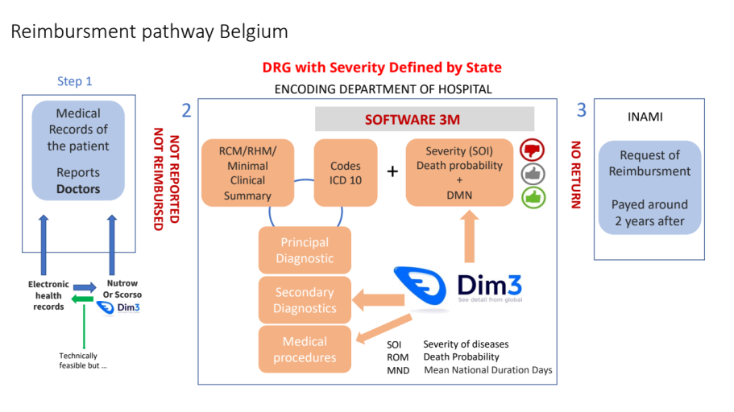

Part 1 : Reference definition

At activation of the project, under the supervision of Dr Lemaire of Vivalia, a retrospective analysis of malnutrition impact on reimbursement will be performed for the years 2022 and 2023.

The methodology will be defined using the geriatric ward patients where malnutrition is high concern and where dietetician data regarding malnutrition are available BUT NOT used in the Medical record of the patient made by the doctors.

Once the methodology approved, the retrospective analysis will be performed on other wards including ICU, Gastroenterology and Oncology.

This reference step will allow to define data of relevant importance to consider in the comparison step.

Part 2 : Impact of Dim3 system

The patients of geriatry, gastroenteroly, oncology and ICU will be screened for malnutrition risk using Scorso on tablet and their results included in Nutrow.

With the Vivalia IT and EHR provider , a methodology to push the malnutrition status will be defined to be sure that this status will be included in the Medical record of the patient base of the reimbursement.

Every 3 months, a comparison with retrospective information will be done to speed up potential publications and dissemination of information toward stakeholders.

The analysis will be performed during 12 months to prepare a final report to be due the 15th month at maximum.

Metrics :

- Impact on secondary diagnostic value
- Impact on medical procedure used.
- % of patients not encoded with malnutrition status Before/after
- RHM Data evolution Before/After
- Amount of annual reimbursement gained using the Dim3 products

- INSTALLATION PROCESS PROCEDURE

FIRST INSTALLATION SCOPE = ICU DEPARTMENT
The installation process of Dim3 system (NUTROW + FEEDIM) in ICU will be monitored and fully reported by IT of Vivalia and Dim3 using an automated common tool to be agreed by both.

Those data will be used to define a “standard” procedure of installation to discuss with prospects and understand feasibility or unfeasibility in the earliest stage of tecnico/commercial discussion.

- TIME SAVING

NUTROW FEEDIM USE / ICU

PART 1 : An analysis of the procedure of clinical nutrition management in the ICU will be performed and time dedicated to this procedure will be computed including feeding pumps management. weakness of procedure will be analyzed toward Espen recommendations. Recommendation of dieticians not followed by ICU will be also questioned.

PART 2 : After implementation of Dim3 system and a training period of 6 weeks, the impact on time dedicated to clinical nutrition will be monitored. Discrepancies in time will be extrapolated on a yearly base on beds base and translated in terms of time gained to increase contact with patient. It will not be expressed as Full time Equivalent in the study.

Results will be exploited in terms of publications.

SCORSO

PART 1 : An analysis of the procedure malnutrition screening will be performed and time dedicated to this procedure will be compute. This analysis will also be dedicated to understand why some patients are not screened.

PART 2 : After implementation of Dim3 Scorso the impact on time dedicated will be monitored. Discrepancies in time will be extrapolated on a yearly base on admissions base and translated in terms of time gained to increase contact with patient. It will not be expressed as Full time Equivalent in the study.

Note on Scorso : the timing gain should be low as manually or digitally, the questionnaire has to be performed. The analysis must include the pathway of data.

- USERS SURVEYS

NUTROW/FEEDIM See Lille Protocol

For Scorso , the survey will be done at the end of the study (15th month).

